1. 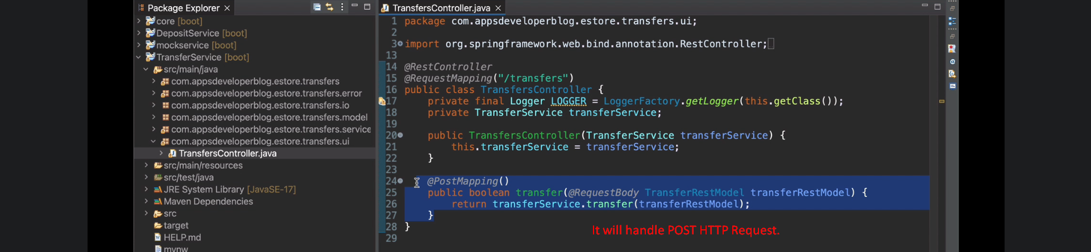
2. 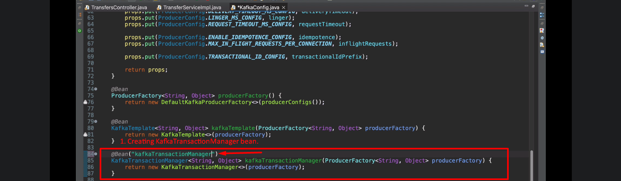
3. Spring Boot needs one transaction manager when we use @Transactional.
   1. If no transaction manager is defined as bean, then spring boot will create one with name “transactionManager” for JpaTransactionManger.
   2. If you define one transaction manager of any type and its bean name is not “transactionManager” then exception.
      1. Spring Boot will not create by default any transaction manager.
   3. Solution: @Transactional(“yourTransactionManagerBeanName”)
4. 